import java.util.Random;

public class RandomNum {

public static void main(String[] args) {

Random rndNum = new Random();

int randomNum = rndNum.nextInt();

System.out.println("Random Number: " + randomNum);

}//end method main

}//end class RandomNum

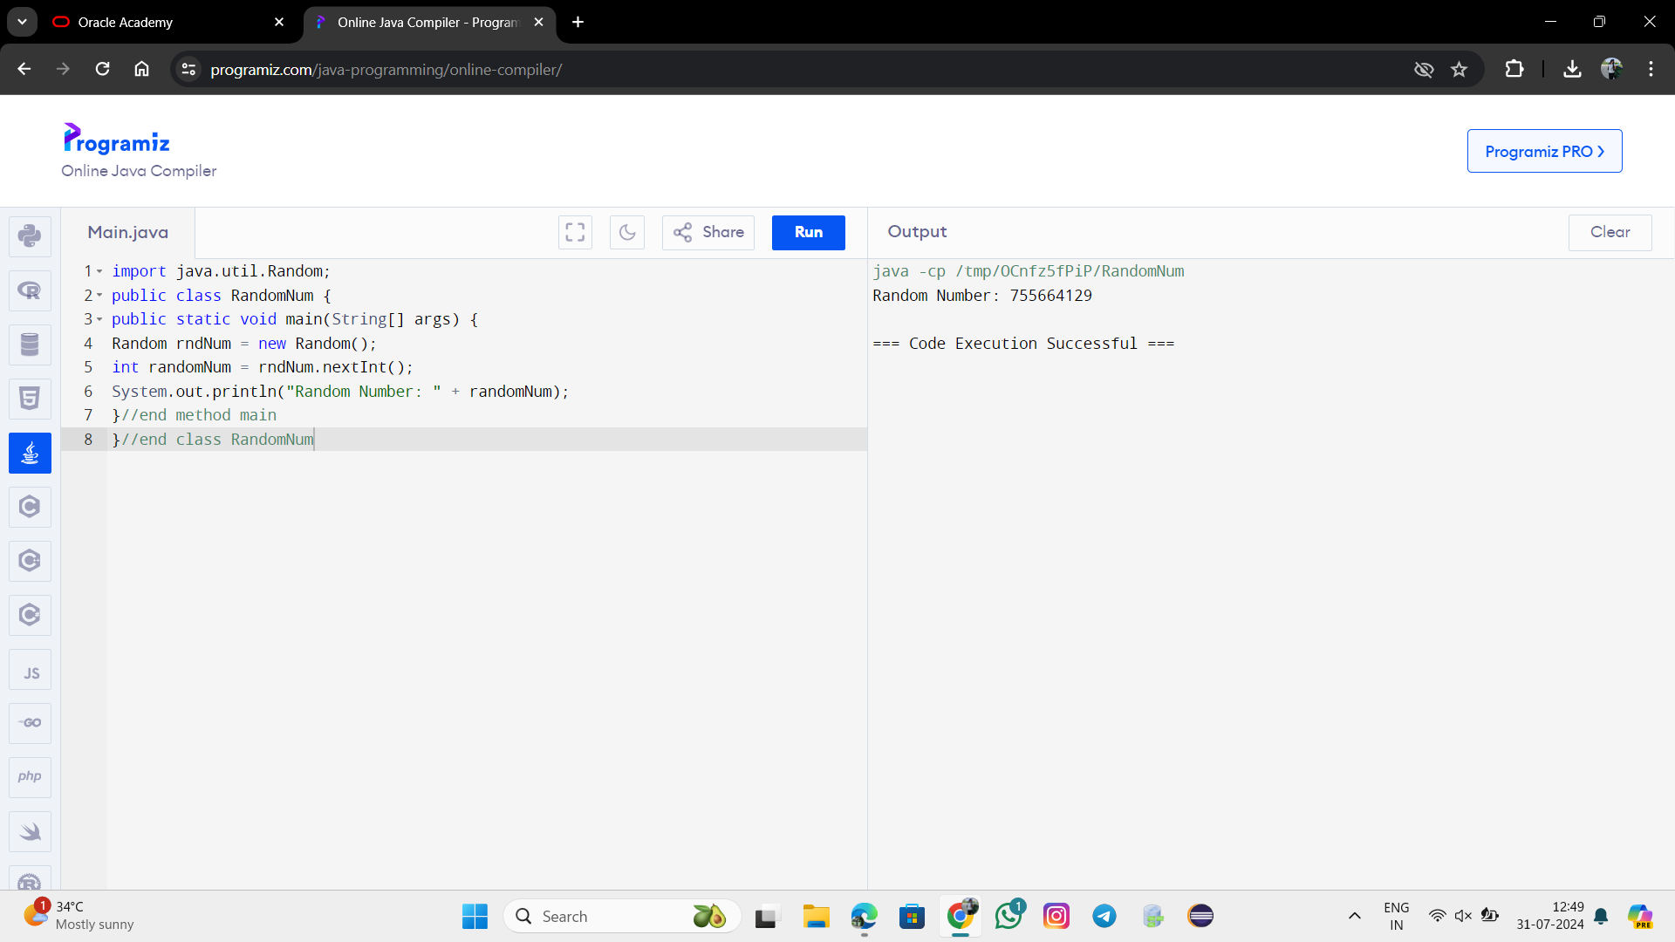

import java.util.Random;

public class RandomNumSeries {

public static void main(String[] args) {

Random num = new Random();

System.out.println("Random Number 1: " + num.nextInt());

System.out.println("Random Number 2: " + num.nextInt());

System.out.println("Random Number 3: " + num.nextInt());

System.out.println("Random Number 4: " + num.nextInt());

System.out.println("Random Number 5: " + num.nextInt());

}//end method main

}//end class RandomNumSeries

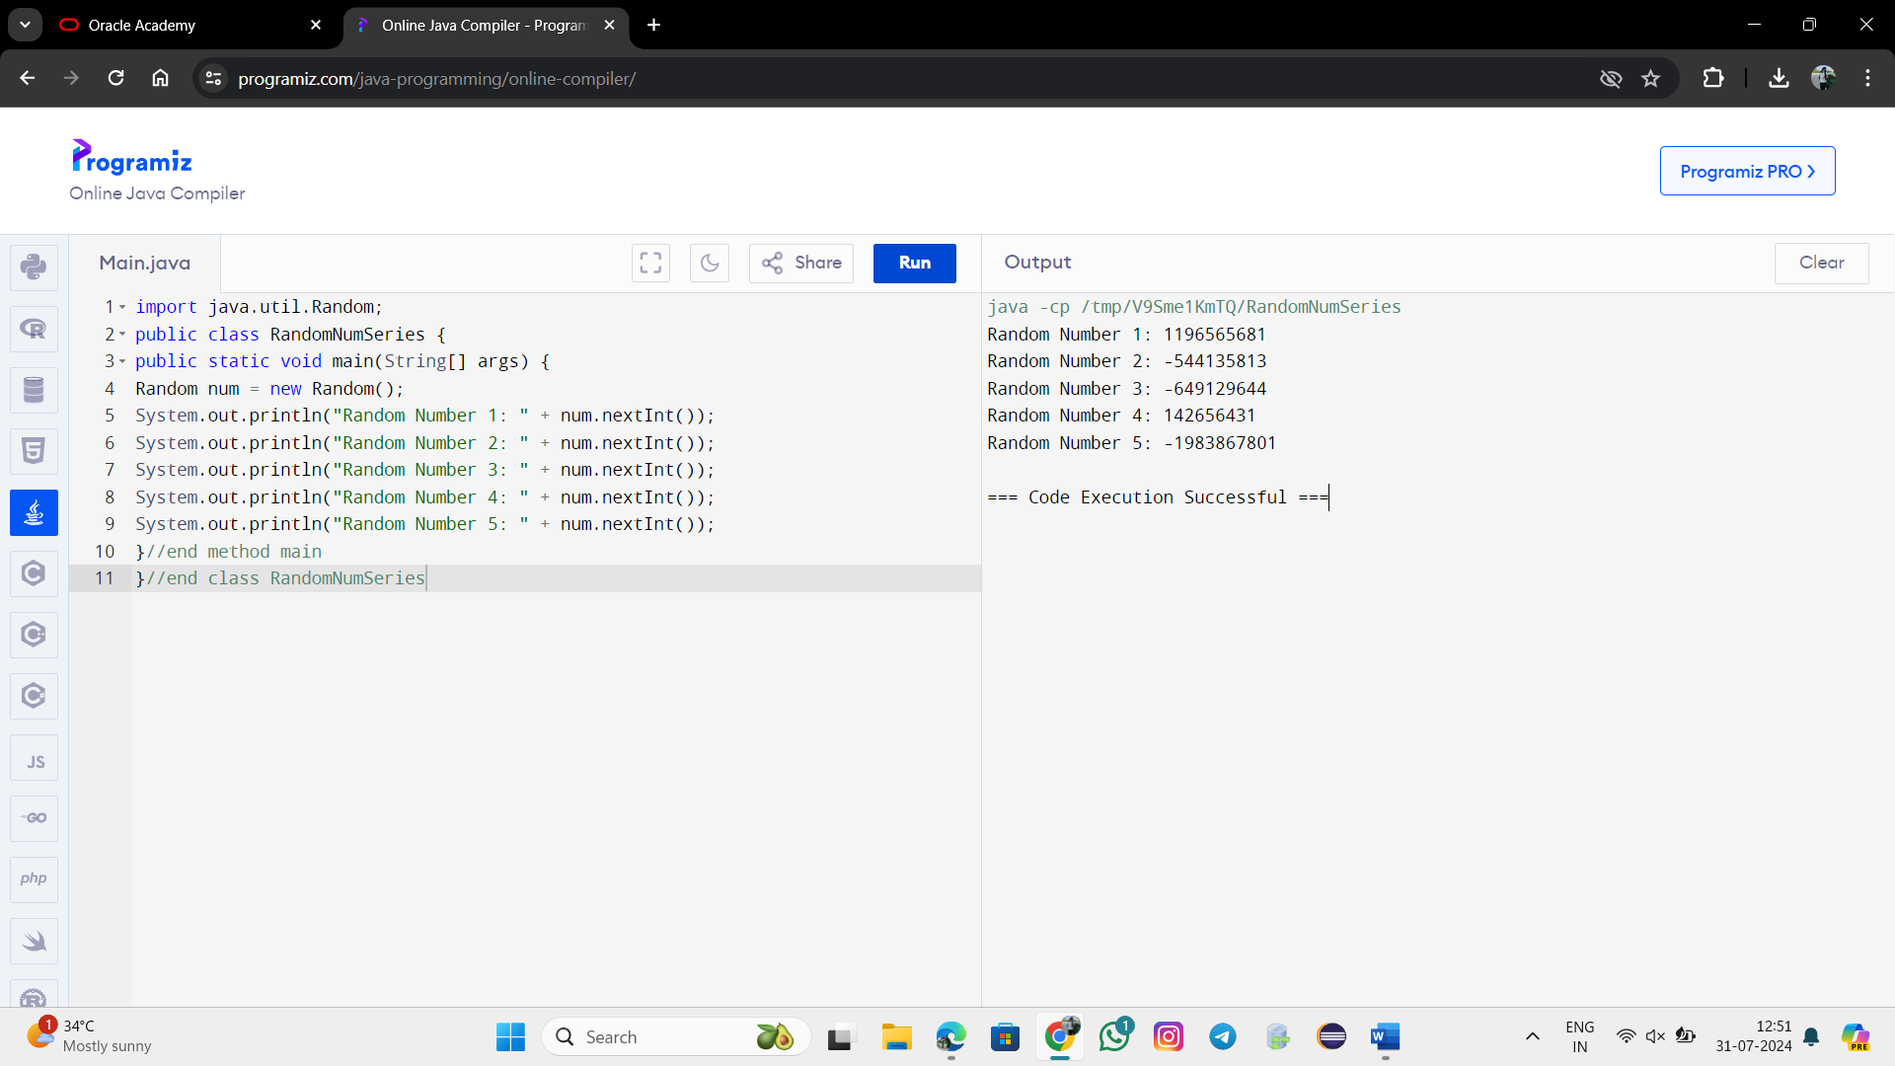

import java.util.Random;

public class RandomDouble

{

public static void main(String[] args)

{

Random num = new Random();

double randomDouble = num.nextDouble();

System.out.println("Random Number: " + randomDouble);

}//end method main

}//end class RandomDouble

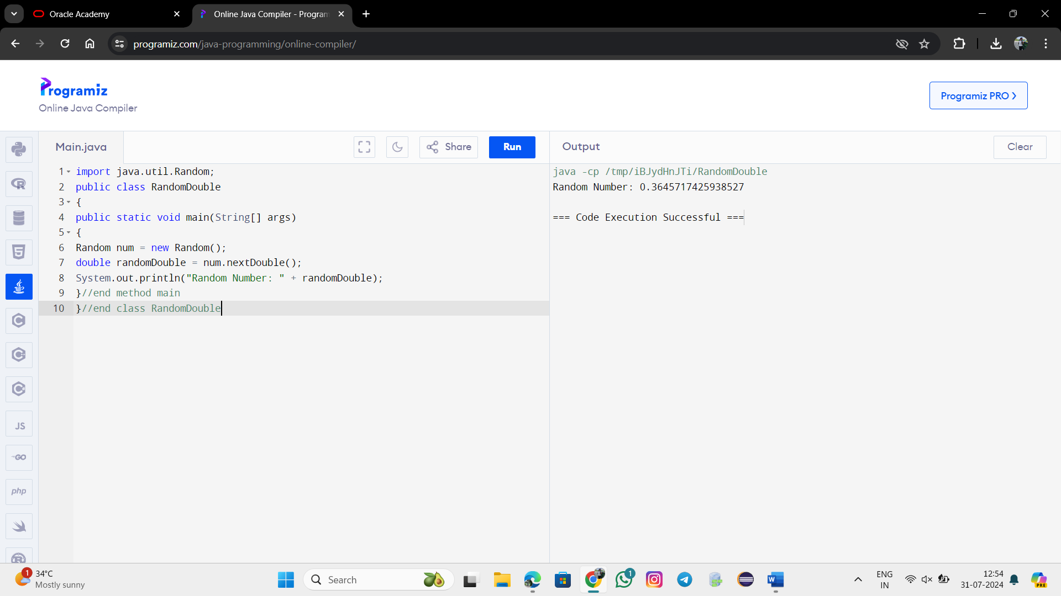

import java.util.Random;

public class main{

public static void main(String[] args) {

Random rand = new Random(20L);

System.out.println("Random Number 1: " + rand.nextInt(26));

System.out.println("Random Number 2: " + rand.nextInt(26));

System.out.println("Random Number 3: " + rand.nextInt(26));

System.out.println("Changing seed to change to sequence");

rand.setSeed(5L);

System.out.println("Random Number 4: " + rand.nextInt(26));

System.out.println("Random Number 5: " + rand.nextInt(26));

System.out.println("Random Number 6: " + rand.nextInt(26));

System.out.println("Setting seed 20 produce previous sequence");

rand.setSeed(20L);

System.out.println("Random Number 7: " + rand.nextInt(26));

System.out.println("Random Number 8: " + rand.nextInt(26));

System.out.println("Random Number 9: " + rand.nextInt(26));

}}//end method mai

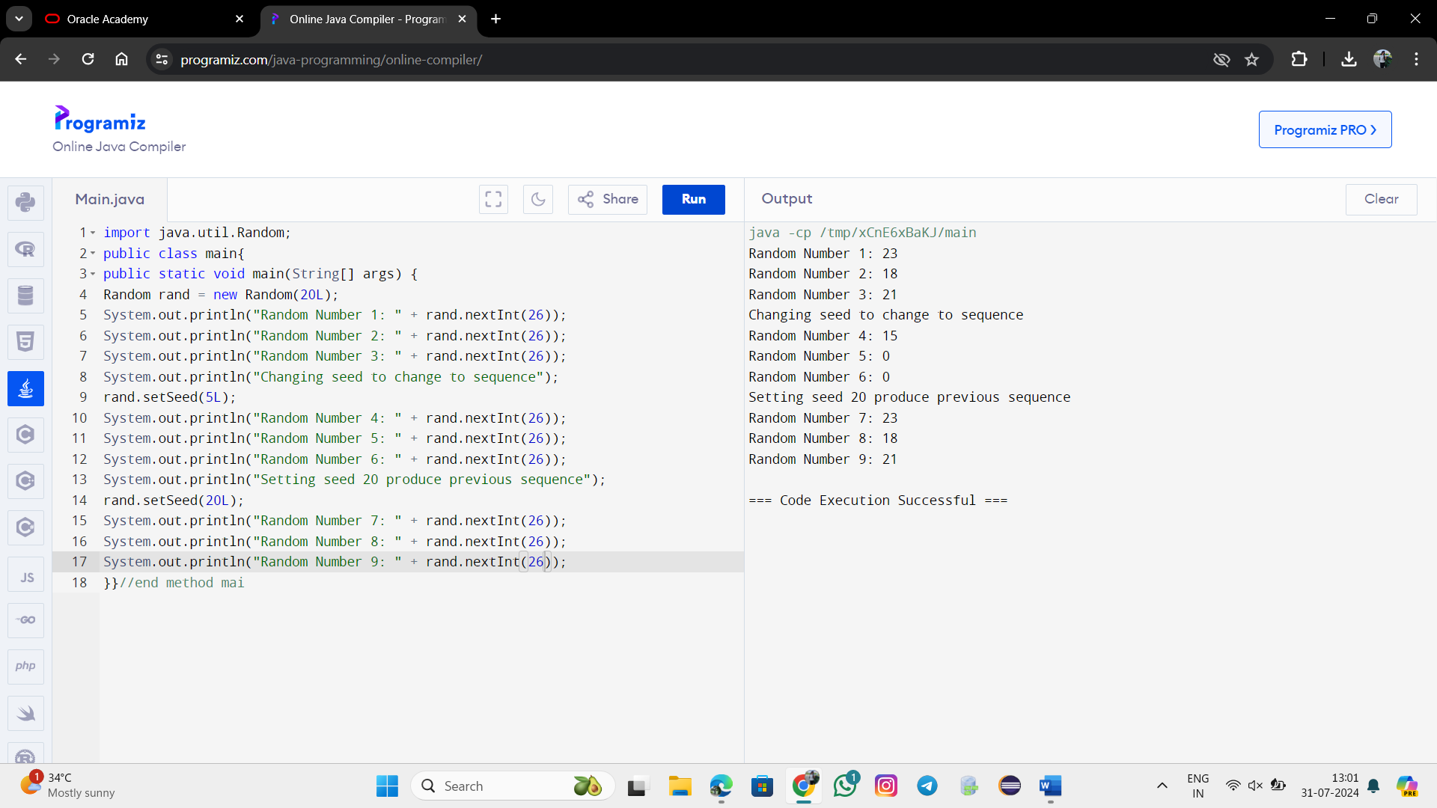

import java.util.Random;

public class FlipCoin {

public static void main(String[] args) {

int numFlips = 10; // Number of coin flips

int headsCount = 0;

int tailsCount = 0;

Random random = new Random();

for (int i = 0; i < numFlips; i++) {

double chance = random.nextDouble();

if (chance < 0.5) {

System.out.println("Flip " + (i + 1) + ": Heads");

headsCount++;

} else {

System.out.println("Flip " + (i + 1) + ": Tails");

tailsCount++;

}

}

// Print the results

System.out.println("Total Heads: " + headsCount);

System.out.println("Total Tails: " + tailsCount);

System.out.printf("Heads Percentage: %.2f%%\n", (headsCount * 100.0 / numFlips));

System.out.printf("Tails Percentage: %.2f%%\n", (tailsCount * 100.0 / numFlips));

}

}

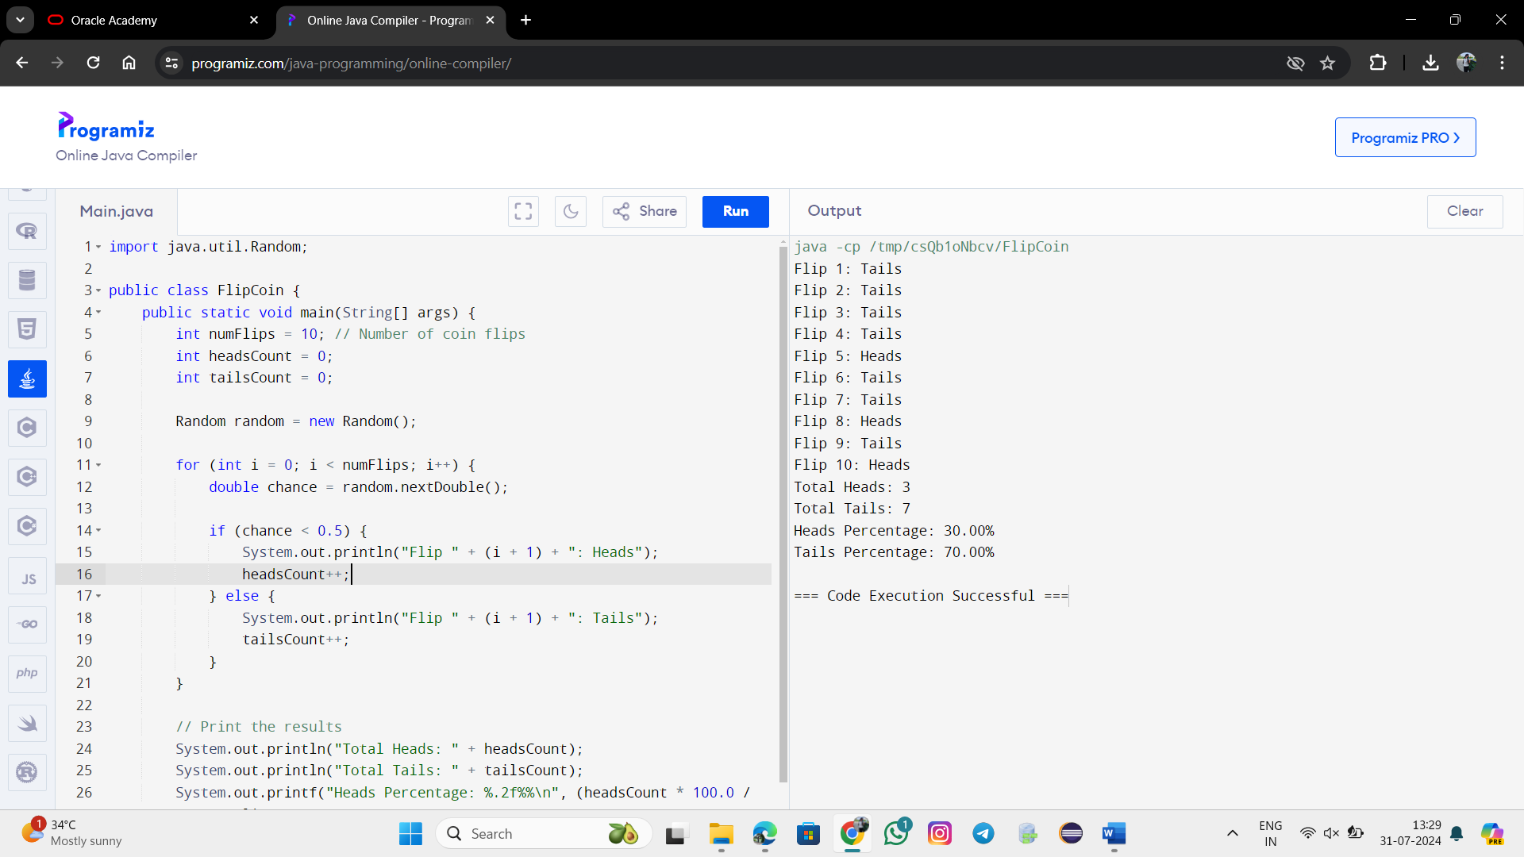

import java.util.Random;

public class Main {

public static void main(String[] args) {

Random rndNum = new Random();

int number = rndNum.nextInt(3);

if (number==0 )

System.out.print("ROCK");

else if (number==1)

System.out.print("PAPER");

else if (number==2)

System.out.print("SCISSOR");

}

}

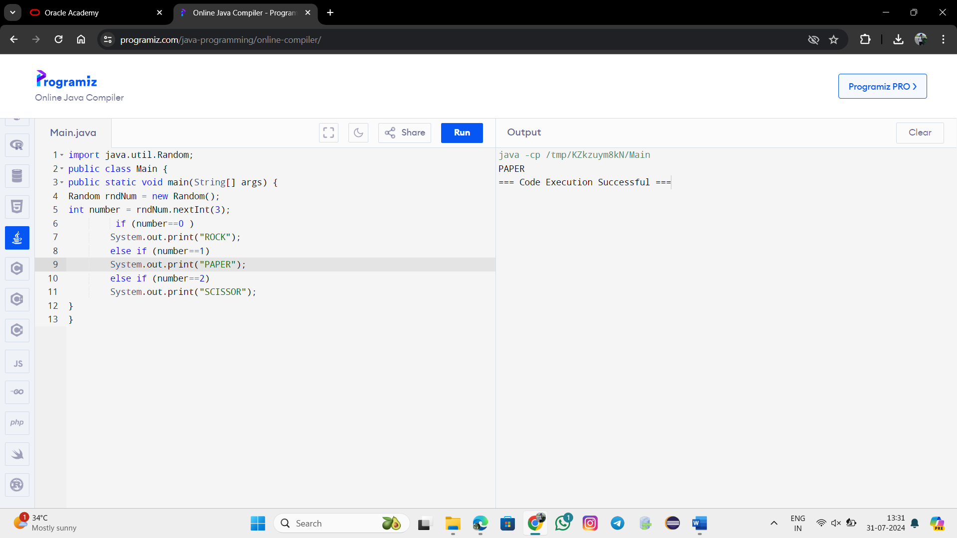

public class MathExample {

public static void main(String[] args) {

double pi = Math.PI;

System.out.println("Value of PI: " + pi);

double number = 16.0;

double squareRoot = Math.sqrt(number);

System.out.println("Square root of " + number + ": " + squareRoot);

double anotherNumber = 25.0;

double anotherSquareRoot = Math.sqrt(anotherNumber);

System.out.println("Square root of " + anotherNumber + ": " + anotherSquareRoot);

}

}

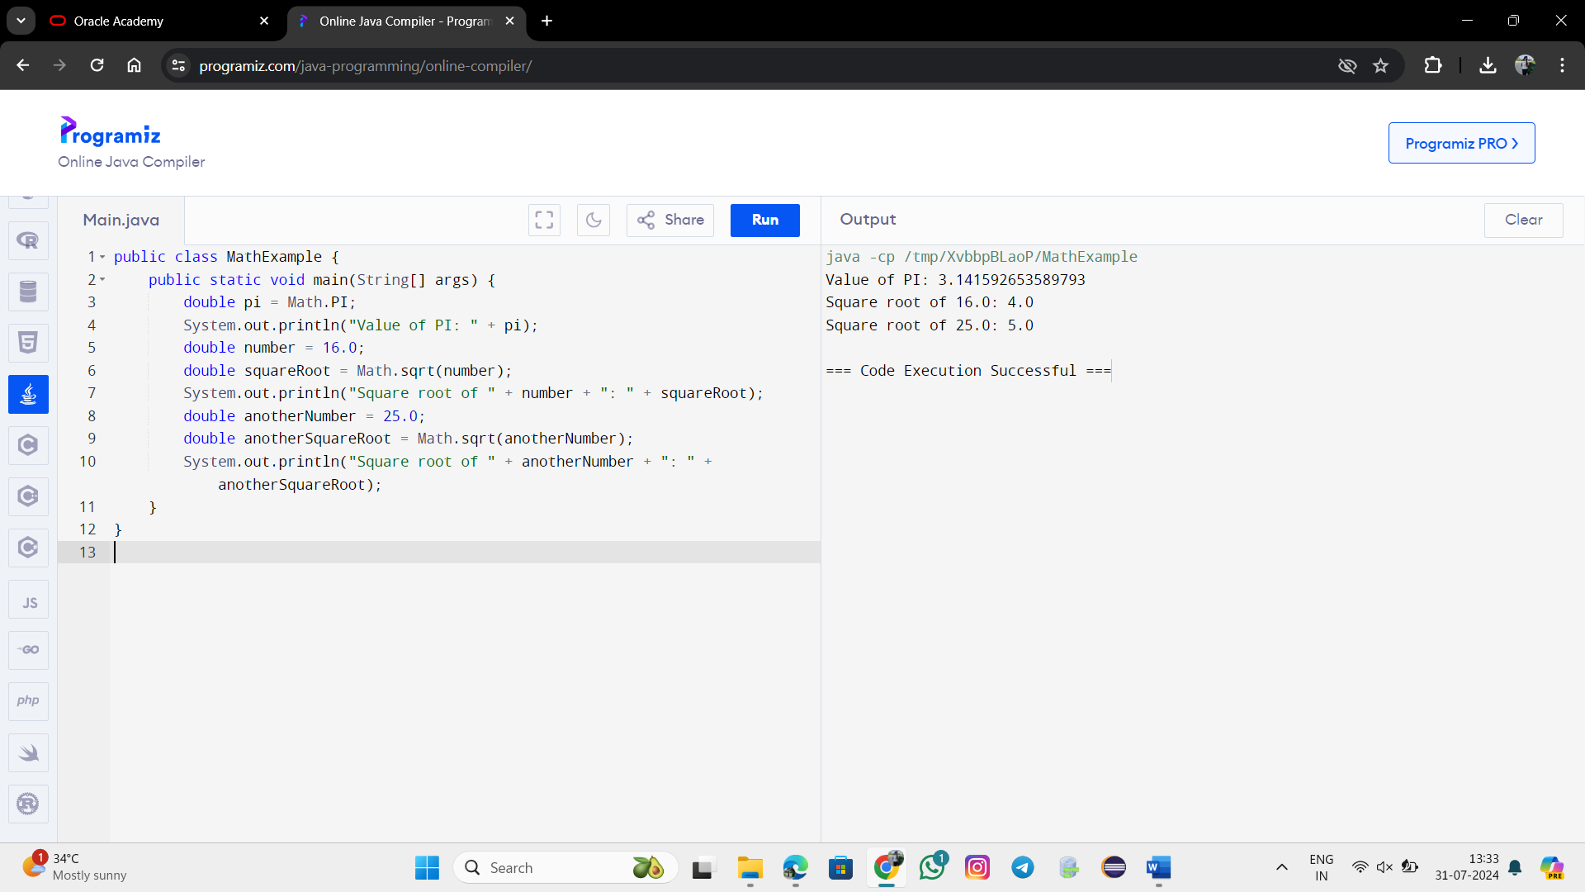

**1. Math.abs(-1.23)**

The Math.abs() method returns the absolute value of a number. For -1.23, the absolute value is 1.23.

**Result:** 1.23

**2. Math.pow(3, 2)**

The Math.pow(double base, double exponent) method returns the value of the base raised to the power of the exponent. For Math.pow(3, 2), it calculates 323^232, which is 9.0.

**Result:** 9.0

**3. Math.sqrt(121.0) - Math.sqrt(256.0)**

The Math.sqrt(double a) method returns the square root of the number.

* Math.sqrt(121.0) is the square root of 121.0, which is 11.0.
* Math.sqrt(256.0) is the square root of 256.0, which is 16.0.

So, Math.sqrt(121.0) - Math.sqrt(256.0) is 11.0 - 16.0, which equals -5.0.

**Result:** -5.0

**4. Math.abs(Math.min(-3, -5))**

* Math.min(int a, int b) returns the smaller of the two numbers. For Math.min(-3, -5), the smaller number is -5.
* Math.abs(-5) returns the absolute value of -5, which is 5.

**Result:** 5

**Summary of Results:**

* Math.abs(-1.23) → 1.23
* Math.pow(3, 2) → 9.0
* Math.sqrt(121.0) - Math.sqrt(256.0) → -5.0
* Math.abs(Math.min(-3, -5)) → 5

These results are based on the operations and methods provided by the Java Math class.

import java.util.Scanner;

public class Main {

public static void main(String args[]) {

Scanner sc = new Scanner(System.in);

System.out.print("Enter the radius: ");

double radius = sc.nextDouble();

double area = Math.PI * radius * radius;

System.out.println("The area of circle is: " + area);

}//end method main

}//end class AreaOfCircle

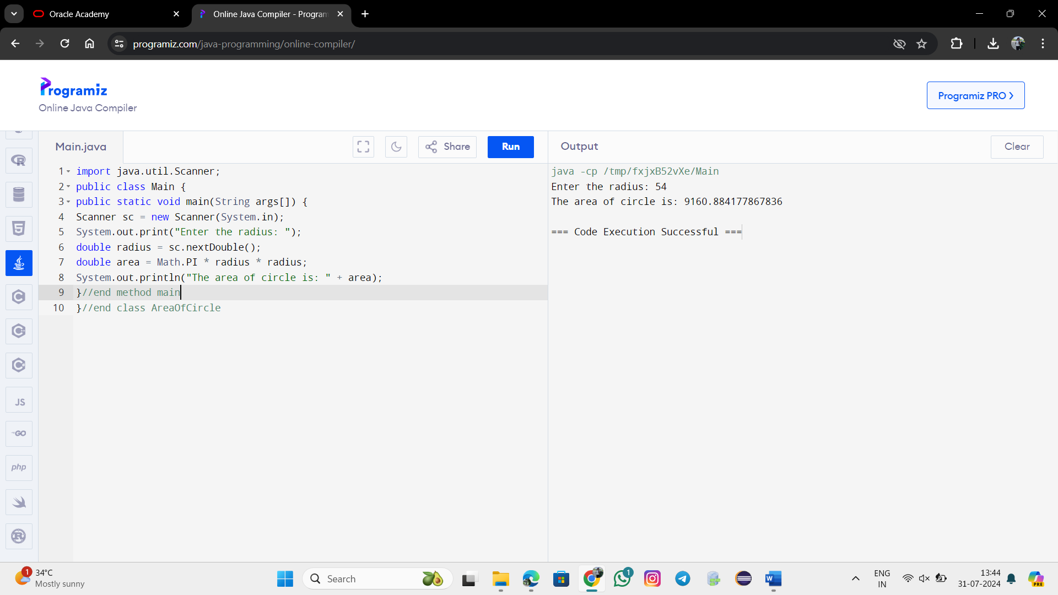

import java.util.Random;

import java.util.Scanner;

public class Lottery {

public static void main(String[] args) {

Scanner numberScanner = new Scanner(System.in);

System.out.print("Enter a number between 1 and 10: ");

int userNum = numberScanner.nextInt();

Random rnd = new Random();

int winningNum = rnd.nextInt(10) + 1;

System.out.println("Your Number: " + userNum);

System.out.println("The winning number is: " + winningNum);

if(winningNum==userNum){

System.out.println("Hooray!! You Won!");

}

else{

System.out.println("HeHe......You Lost");

}

}

}

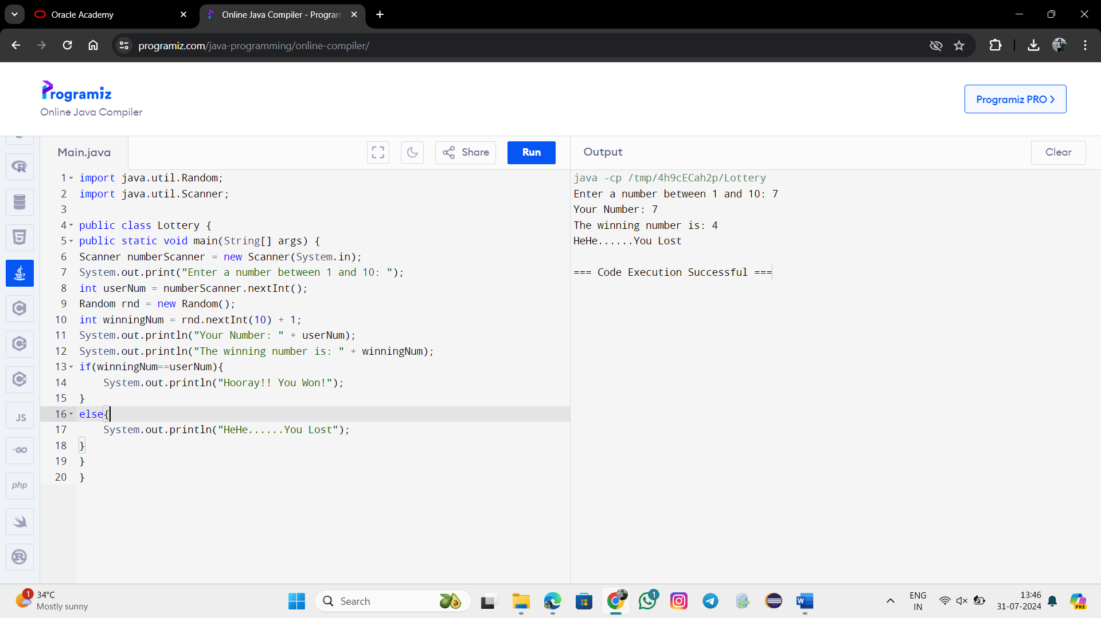

public class ComputeBMI {

public static void main(String[] args) {

double weightInPounds = 150; // weight in pounds

double heightInInches = 65; // height in inches

double bmi = (703 * weightInPounds) / (heightInInches * heightInInches);

double roundedBmi = Math.round(bmi * 100.0) / 100.0;

System.out.println("The BMI is " + roundedBmi);

}

}

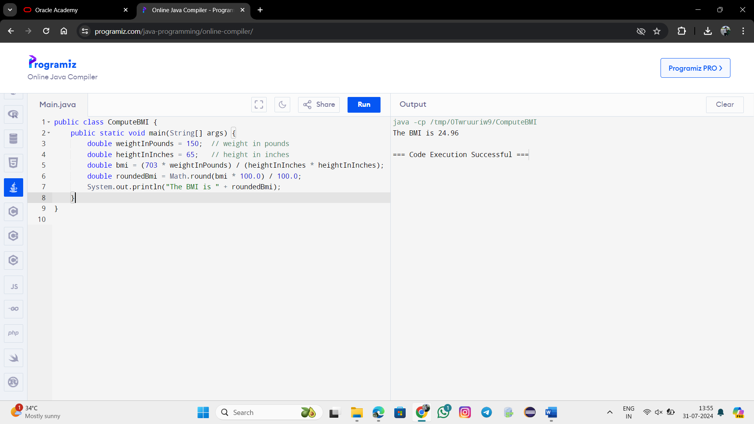

import java.util.Scanner;

public class ComputeBMI {

public static void main(String[] args) {

Scanner scanner = new Scanner(System.in);

System.out.print("Enter the weight in pounds: ");

double weightInPounds = scanner.nextDouble();

System.out.print("Enter the height in inches: ");

double heightInInches = scanner.nextDouble();

double bmi = (703 * weightInPounds) / (Math.pow(heightInInches, 2));

int roundedBmi = (int) Math.round(bmi);

System.out.println("Your Body Mass Index is " + roundedBmi);

}

}

